Table 2. Temperature dependent equations for predicting the thermophysical properties of the major components of food. (From Choi & Okos, 1986), and Murakami and Okos, 1988).
Property | Food Component | Temperature Dependent Equation | Eq. No.
Specific heat | Protein |  | (6)
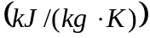 | Carbohydrate |  | (7)
 | Fiber |  | (8)
 | Ash |  | (9)
 | Fat |  | (10)
 | Water 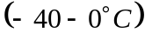 |  | (11)
 | Water 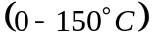 |  | (12)
 | Ice | 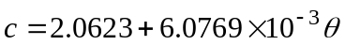 | (13)
Density | Protein | 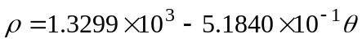 | (14)
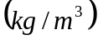 | Carbohydrate | 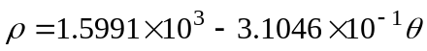 | (15)
 | Fiber | 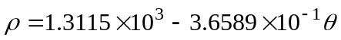 | (16)
 | Ash | 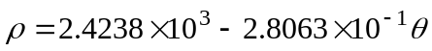 | (17)
 | Fat | 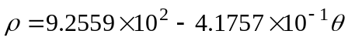 | (18)
 | Water |  | (19)
 | Ice | 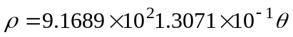 | (20)
Thermal | Protein |  | (21)
Conductivity | Carbohydrate |  | (22)
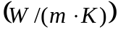 | Fiber |  | (23)
 | Ash |  | (24)
 | Fat |  | (25)
 | Water |  | (26)
 | Ice |  | (27)
 | Air | 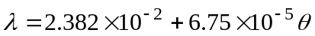 | (27a)
Thermal | Protein |  | (28)
Diffusivity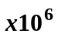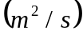 | Carbohydrate |  | (29)
Thermal | Fiber |  | (30)
Diffusivity | Ash |  | (31)
 | Fat |  | (32)
 | Water |  | (33)
 | Ice |  | (34)

